Lab Assignment

Task
Create a step-by-step lab Setup document with screenshots.

What to Do
- Choose one lab topic
- Perform it yourself
- Write all steps clearly
- Add screenshots

Format (Follow This)
Title:
Objective:
Requirements:
Steps:

Step 1:
- Screenshot:

Step 2:
- Screenshot:

Step 3:
- Screenshot:
(Continue…)
Result:

Example (Follow This Style)
Title: Install Kali Linux
Objective: Install Kali Linux on system
Minimum System Requirements:

- Processor: 64-bit Intel Core i3/i5/i7 or AMD E1 equivalent.
- RAM: 2 GB (4–8 GB recommended for smoother operation).
- Storage: 20 GB HDD or SSD space (Free space).

Step 1: Download kali Linux ISO File
- Go to official website: https://www.kali.org/get-kali/#kali-virtual-machines
- Download the Pre-Build Image for Virtual Box
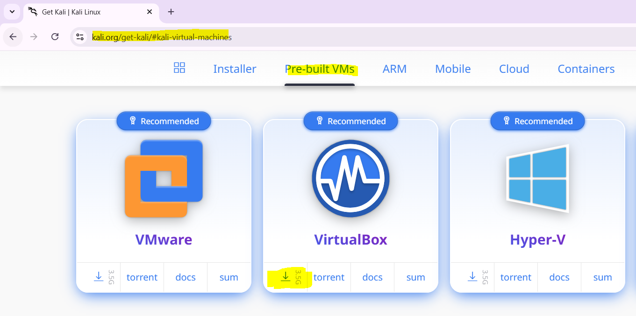
After Download click on executable file and proceed with the guided installation steps (next > next > install)
Step 2: Download Virtual Box
- Go to official website: https://www.virtualbox.org/wiki/Downloads
- Download Windows Host
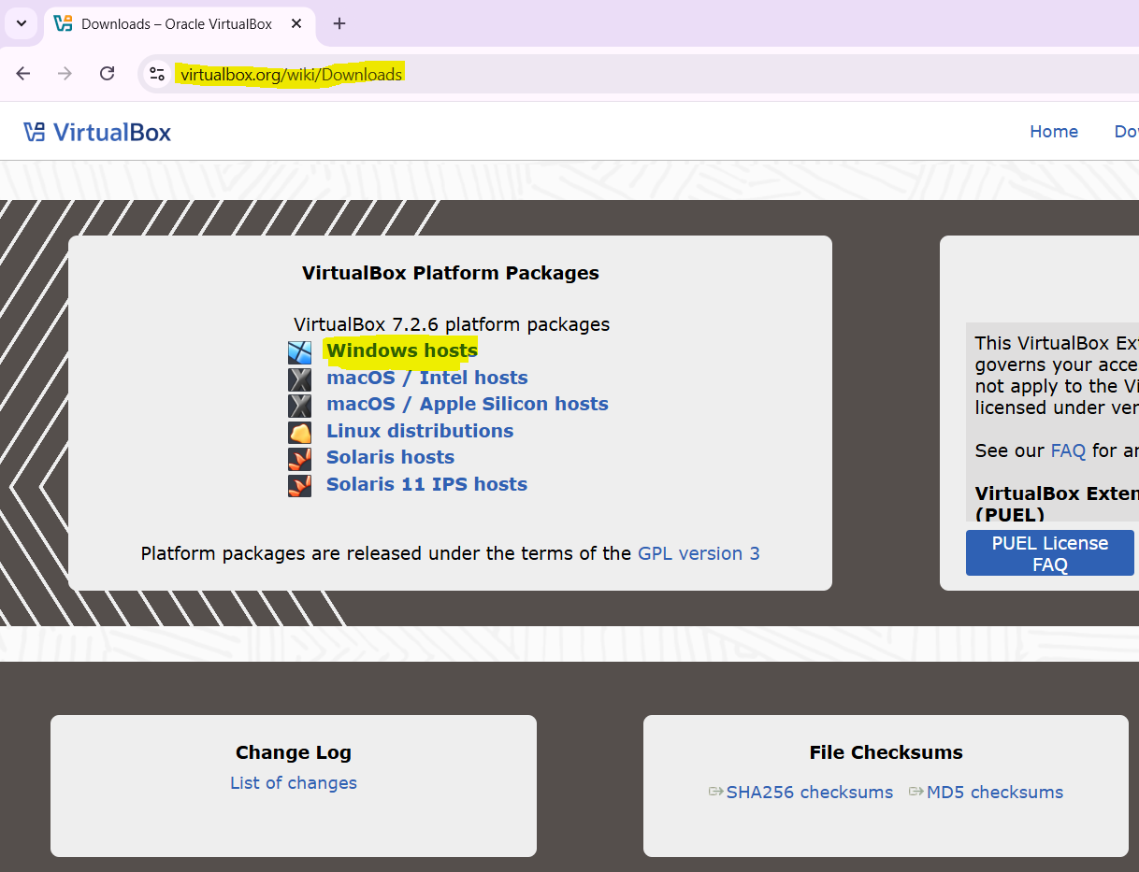
Continue………………

